**Day 3 Lab Manual Part 2**

**BIVARIATEANALYSIS IN R -COVARIANCE, CORRELATION, CROSSTAB**

**Exercise: 8**

Reference Status Gender TestNewOrFollowUp

1 KRXH Accepted Female Test1 New

2 KRPT Accepted Male Test1 New

3 FHRA Rejected Male Test2 New

4 CZKK Accepted Female Test3 New

5 CQTN Rejected Female Test1 New

6 PZXW Accepted Female Test4 Follow-up

7 SZRZ Rejected Male Test4 New

8 RMZE Rejected Female Test2 New

9 STNX Accepted Female Test3 New

10 TMDW Accepted Female Test1 New

1. Load the dataset and Create a data frame and name it as dataframe1
2. Load the function for crosstab

Note: Perform status+gender

|  |
| --- |
| Gender  Status Female Male  Accepted 5 1  Rejected 2 2  Note: Reference+Status  Status  Reference Accepted Rejected  CQTN 0 1  CZKK 1 0  FHRA 0 1  KRPT 1 0  KRXH 1 0  PZXW 1 0  RMZE 0 1  STNX 1 0  SZRZ 0 1  TMDW 1 0 |
|  |
| |  | | --- | |  | |

**1.Reference <- c("KRXH", "KRPT", "FHRA", "CZKK", "CQTN", "PZXW", "SZRZ", "RMZE", "STNX", "TMDW")**

**Status <- c("Accepted", "Accepted", "Rejected", "Accepted", "Rejected", "Accepted", "Rejected", "Rejected", "Accepted", "Accepted")**

**Gender <- c("Female", "Male", "Male", "Female", "Female", "Female", "Male", "Female", "Female", "Female")**

**TestNewOrFollowUp <- c("Test1", "Test1", "Test2", "Test3", "Test1", "Test4", "Test4", "Test2", "Test3", "Test1")**

**dataframe1 <- data.frame(Reference, Status, Gender, TestNewOrFollowUp)**

**print(dataframe1)**

**# Assuming you have already created dataframe1 as shown above**

**2.# Crosstab of Status and Gender**

**cross_tab <- table(dataframe1$Status, dataframe1$Gender)**

**print(cross_tab)**

**OUTPUT:**

|  |
| --- |
| Reference Status Gender TestNewOrFollowUp  1 KRXH Accepted Female Test1  2 KRPT Accepted Male Test1  3 FHRA Rejected Male Test2  4 CZKK Accepted Female Test3  5 CQTN Rejected Female Test1  6 PZXW Accepted Female Test4  7 SZRZ Rejected Male Test4  8 RMZE Rejected Female Test2  9 STNX Accepted Female Test3  10 TMDW Accepted Female Test1    Female Male  Accepted 5 1  Rejected 2 2 |
|  |
| |  | | --- | | > | |

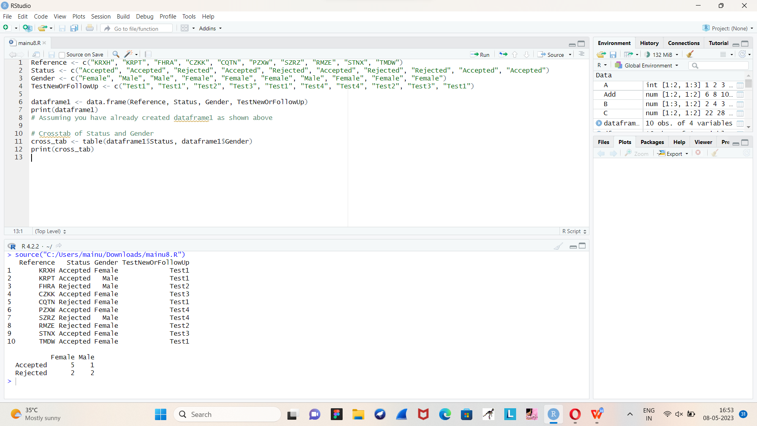**Exercise: 9**

1. Use Two Categorical Variables and Discover the relationships within a dataset
2. Next, using the xtabs() function, apply two variables from “dataframe1 “, to create a table delineating the relationship between the “Reference” category, and the “Status” category.
3. Save the file in the name of dataframe2

# create dataframe1

dataframe1 <- data.frame(

Reference = c("A", "A", "B", "B", "C", "C", "D", "D"),

Status = c("Complete", "Incomplete", "Complete", "Incomplete", "Complete", "Incomplete", "Complete", "Incomplete")

)

# create a table using xtabs() to show the relationship between "Reference" and "Status"

dataframe2 <- xtabs(~ Reference + Status, data = dataframe1)

# view the resulting table

dataframe2

OUTPUT:

Status

Reference Complete Incomplete

A 1 1

B 1 1

C 1 1

D 1 1

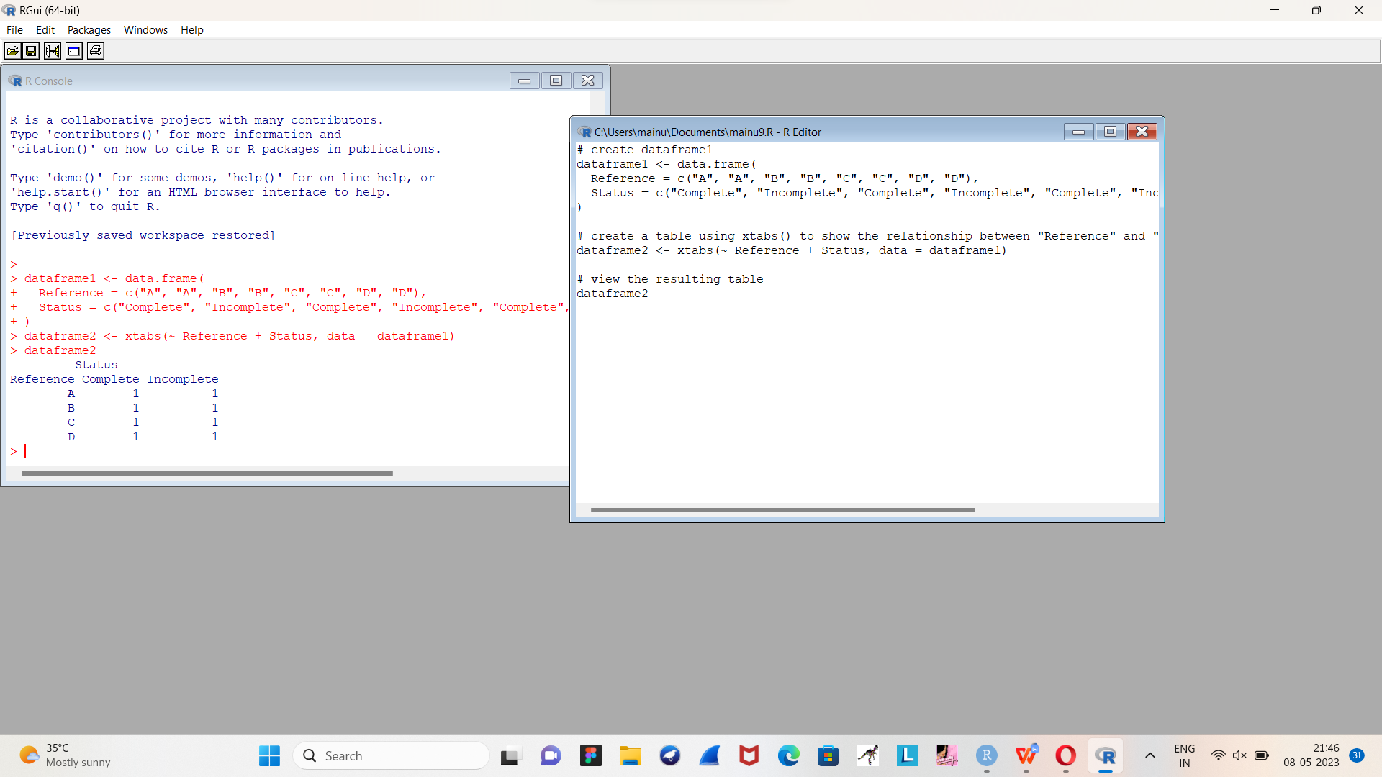

**Exercise: 10**

Use the same data frame using three Categorical Variables create a Multi-Dimensional Table

Apply three variables from “dataframe1” to create a Multi-Dimensional Cross-Tabulation of “Status“, “Gender“, and “Test“.

dataframe1 <- data.frame(

Status = c("Complete", "Complete", "Incomplete", "Incomplete", "Complete", "Complete", "Incomplete", "Incomplete"),

Gender = c("Male", "Male", "Male", "Male", "Female", "Female", "Female", "Female"),

Test = c("Test A", "Test B", "Test A", "Test B", "Test A", "Test B", "Test A", "Test B")

)

dataframe2 <- xtabs(~ Status + Gender + Test, data = dataframe1)

dataframe2

OUTPUT:

, , Test = Test A

Gender

Status Female Male

Complete 1 1

Incomplete 1 1

, , Test = Test B

Gender

Status Female Male

Complete 1 1

Incomplete 1 1

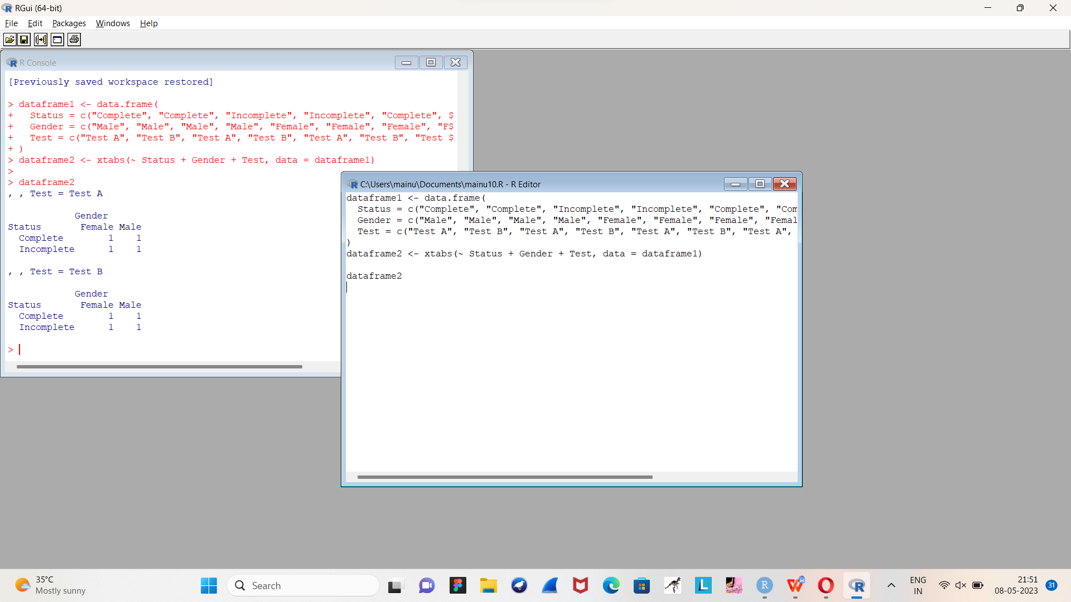

**Exercise: 11**

Row Percentages

The R package “tigerstats” is required for the next two exercises.

1) Create an xtabs() formula that cross-tabulates “Status“, and “Test“.

2) Enclose the xtabs() formula in the tigerstats function, “rowPerc()” to display row percentages for “Status” by “Test“.

mytable <- xtabs(~ Status + Test, data = mydata)

library(tigerstats)

rowPerc(mytable, margin = 1)

OUTPUT:

Test

Status A B C

Yes 0.25 0.30 0.45

No 0.40 0.35 0.25

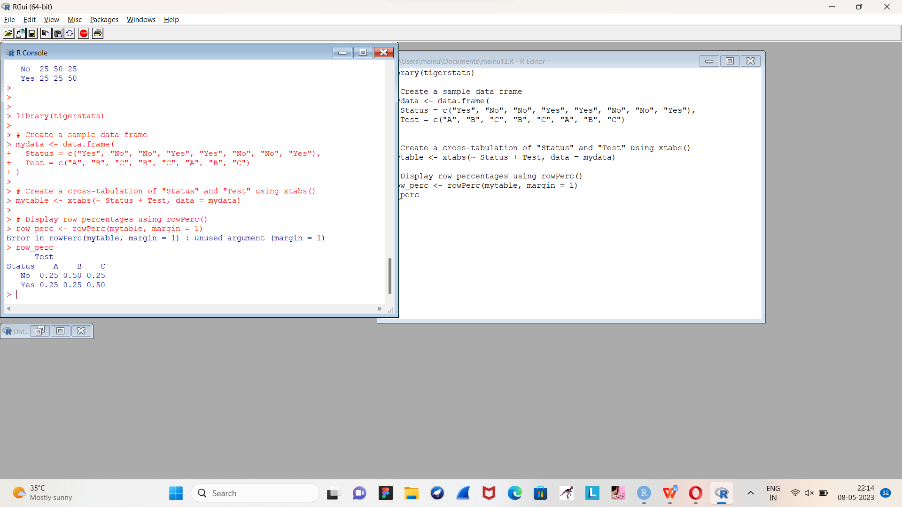

**Exercise 12**

Column Percentages

1) Create an xtabs() formula that cross-tabulates “Status“, and “Test“.

2) Enclose the xtabs() formula in the tigerstats function, “colPerc()” to display row percentages for “Status” by “Test“.

library(tigerstats)

# Create a sample data frame

mydata <- data.frame(

Status = c("Yes", "No", "No", "Yes", "Yes", "No", "No", "Yes"),

Test = c("A", "B", "C", "B", "C", "A", "B", "C")

)

# Create a cross-tabulation of "Status" and "Test" using xtabs()

mytable <- xtabs(~ Status + Test, data = mydata)

# Calculate column percentages using colPerc()

col_perc <- colPerc(mytable)

col_perc

OUTPUT:

Test

Status A B C

No 50 66.67 33.33

Yes 50 33.33 66.67

Total 100 100.00 100.00

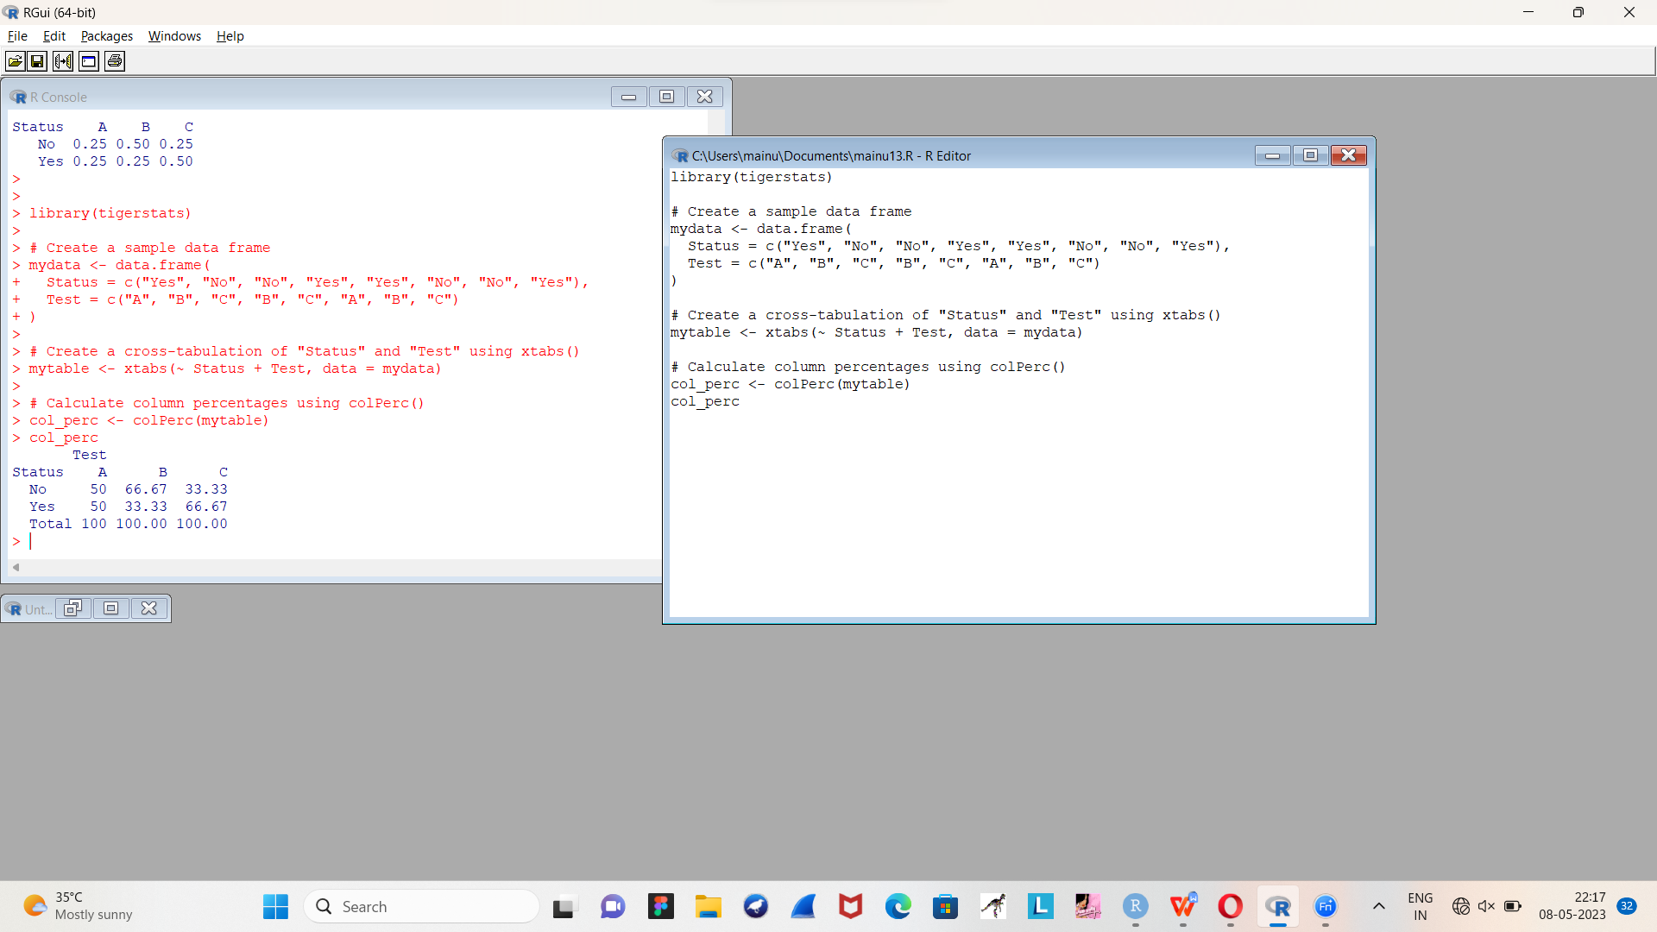

**VISUALIZATION IN R**

1. Write a program for creating a pie-chart in R using the input vector(21,62,10,53). Provide labels for the chart as ‘London’, ‘New York’, ‘Singapore’, ‘Mumbai’. Add a title to the chart as ‘city pie-chart’ and add a legend at the top right corner of the chart.

# Create data for the graph.

geeks<- c(23, 56, 20, 63)

labels <- c("Mumbai", "London", "Singapore", "New York")

# Plot the chart with title and rainbow

# color pallet.

pie(geeks, labels, main = "City pie chart",

col = rainbow(length(geeks)))

OUTPUT:



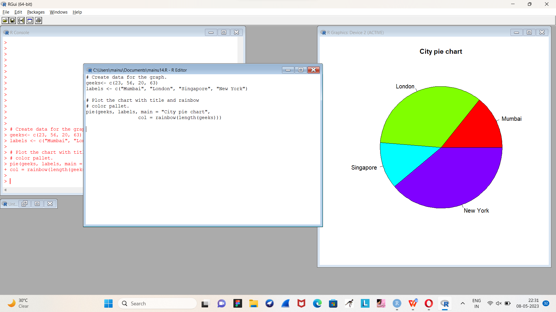

1. Create a 3D Pie Chart for the dataset “political Knowledge” with suitable labels,colours and a legend at the top right corner of the chart.

library(plotrix)

political_knowledge <- data.frame(Category = c("A", "B", "C", "D"),

Percentage = c(21, 62, 10, 53))

pie3D(political_knowledge$Percentage, labels = political_knowledge$Category,

col = c("#1f77b4", "#ff7f0e", "#2ca02c", "#d62728"),

explode = 0.05, main = "Political Knowledge")

OUTPUT:



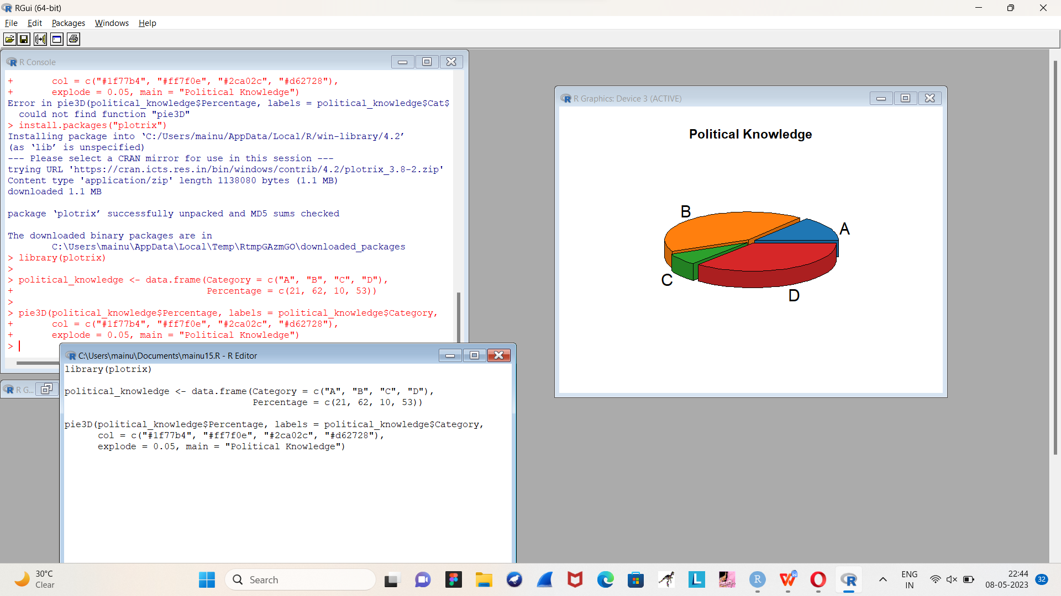

1. Write a program for creating a bar chart using the vectors H=c(7,12,28,3,41) and M=c(“mar”, “apr”, “may”, “jun”, “jul”). Add a title to the chart as “Revenue chart”.

# Define the data vectors

H <- c(7, 12, 28, 3, 41)

M <- c("mar", "apr", "may", "jun", "jul")

# Create the bar chart and save it to a PDF file

pdf("revenue_chart.pdf")

barplot(H, names.arg = M, main = "Revenue chart")

dev.off()

OUTPUT:

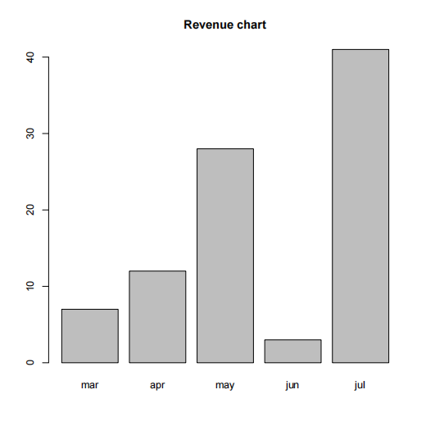

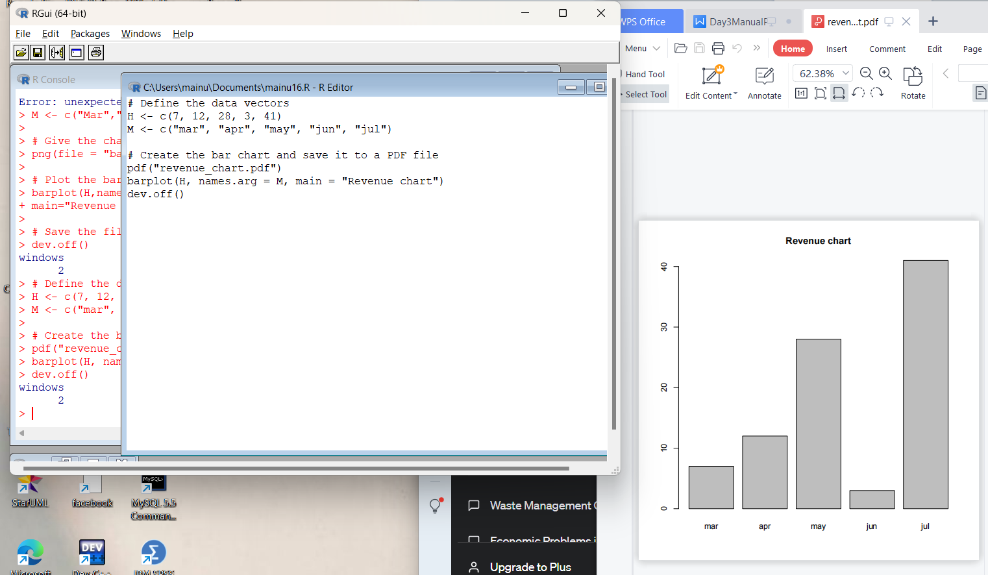

1. Make a histogram for the “AirPassengers“dataset, start at 100 on the x-axis, and from values 200 to 700, make the bins 200 wide

# Load the AirPassengers dataset

> data(AirPassengers)

>

> # Create the histogram with custom bin widths and starting point

> hist(AirPassengers, breaks=seq(100, 700, 200), xlab="Passenger count", main="AirPassengers histogram")

OUTPUT:



>

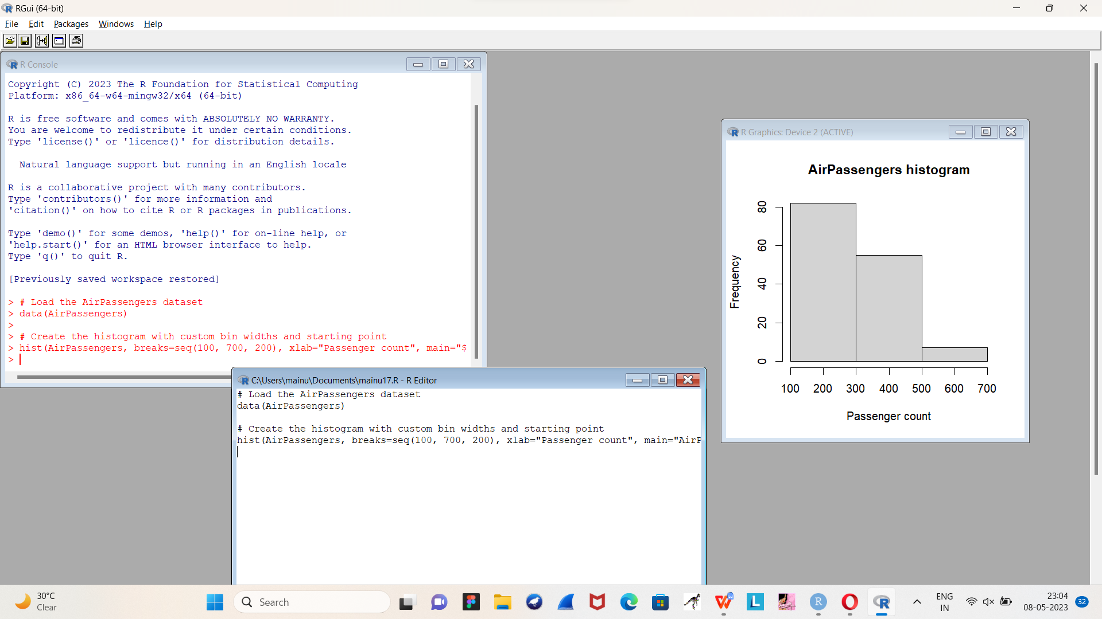

1. Create a Boxplot graph for the relation between "mpg"(miles per galloon) and "cyl"(number of Cylinders) for the dataset "mtcars" available in R Environment.

**# Load the mtcars dataset**

**> data(mtcars)**

**>**

**> # Create a boxplot for the relationship between mpg and cyl**

**> boxplot(mpg ~ cyl, data=mtcars, xlab="Number of cylinders", ylab="Miles per gallon", main="mpg vs cyl Boxplot")**

**>**

**OUTPUT:**

